Student Spotlight
Gideon Smith
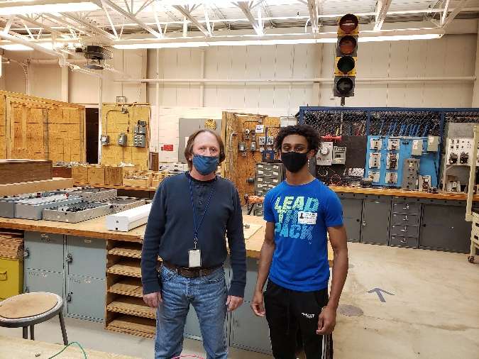
Name and Location of Internship:
United States Coast Guard Yard
Baltimore, MD
Job title/department:
Electrical Helper/Intern
Supervisor's name and title:
Ken Puller (Electro Group Supervisor)
Tell me about yourself:
I completed Level II of the Electricity Program at CAT North last school year. As a senior I have been part of the Work Study Program at CAT North. I have aspirations of becoming an Electrical Engineer in my future.
Why did you choose to pursue an internship?
The reason that I wanted to pursue an internship is to expand my knowledge in the electrical field. I always loved learning about how and electricity work the way it does. Therefore, I learned more about electricity, my field/trade, and myself by pursuing an internship.
Daily internship duties:
As an intern my main duty is to learn as much as I can. Therefore, I am constantly being put on various electrical systems and learning how t put them together, how they work, and testing the systems for any problems.
Coolest project you worked on:
One of the coolest projects I have worked on is when I terminated wires for a bow thruster motor. The cable I was working with was about the size of my forearm and very hard to bend. In the end I got the job done while working with a cable I have never seen before.
One thing you have learned that you will take with you:
One thing I will take with me when I continue with my life is my people skills. I have learned a lot about various electrical equipment and work-related equipment but learning how to deal with different people is essential in my life.
Best piece of advice you would give to a junior who is looking to pursue an internship:
My advice to any junior looking to pursue an internship is too be prepared to learn. Throughout my internship I have learned a lot about my line of work and about myself. Going through an internship won’t only provide you with the skills needed in your field; it will also help you grow and learn more about yourself as a person.
Describe one experience at your internship that you will never forget:
One experience I will never forget is when I was assigned to dismount, mount, and connect a controller to a pump motor. That was the first time I was ever assigned to do a task alone with not help, and I felt accomplished when I finished that task.
What are your plans after graduation?
Currently I have not chosen what path I want to take when I graduate. However, I am leaning more towards going to college to pursue an Electrical Engineering degree and learn even more about electricity. Even though I am on the fence, I can not wait to see what the future has in store for me.
Testimonial from Supervisor
“Gideon Smith has been working with my crew of electricians since late September 2020. In that time, Mr. Smith has maintained his positive attitude and drive to succeed the entire time. Gideon has a passion to learn shipyard electrical/electronic trade and is often requested by senior mechanics to assist them. Mr. Smith is a pleasure to work with and has a bright future in whatever path he chooses”
Ken Puller, Supervisor Electro Group

